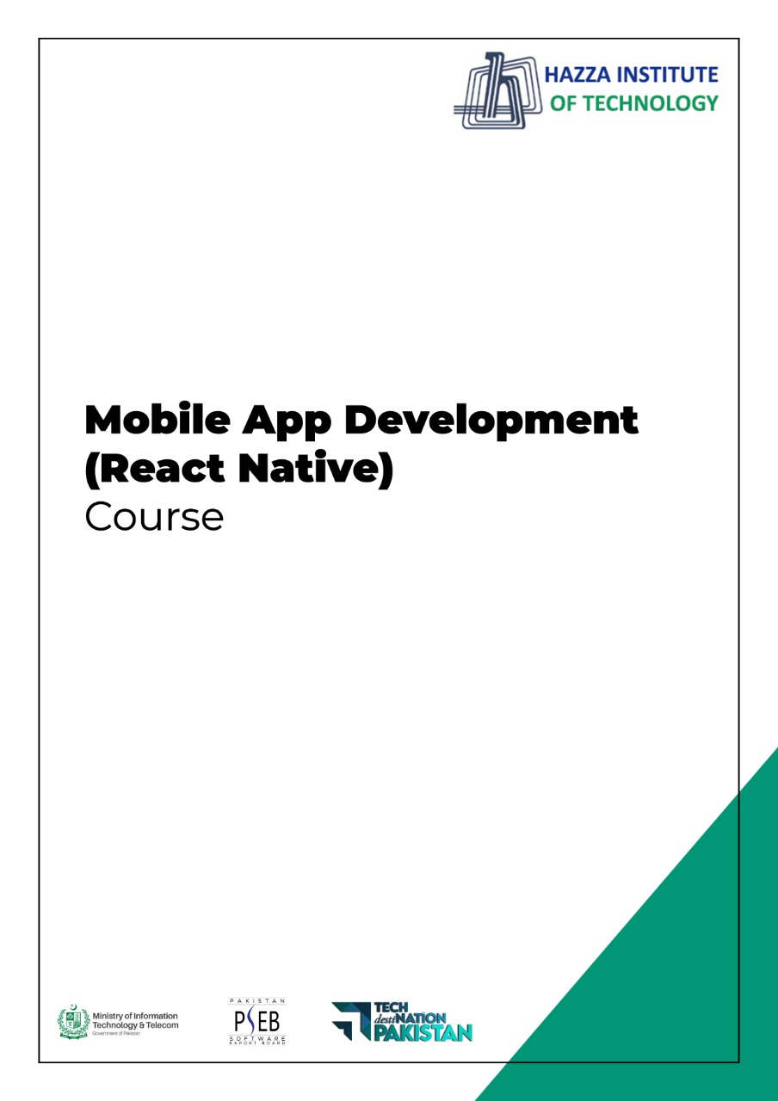

**(Flutter)**

Flutter Lab 5 (Session 1)

**Total Time:**

**3 hours (session-1)**

**Pre-Lab Activities:**

* + Basics of Flutter Scoffold Widget
  + Familiar with Development Coding Editor

**Learning Outcomes:**

* + Learn Flutter Appbar
  + Learn Flutter BootomBar
  + Learn Flutter Navigation Bar
  + Learn Flutter MenuBar

**Student Activities:**

* + Complete the pre-lab activities
  + Practicing Basic Widgets
  + Practice for Scaffold

**Lab Tasks -1:**

* Design the UI accoriding to below given image.
* Develop Appbar with titile, leading and Action properties
* Develop Tabbar with BottomBar, consist on Call Camera and Chat Icons
* 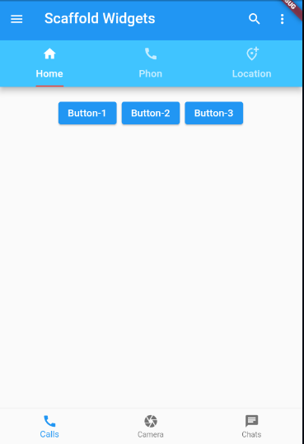Develop ButtonBar having three buttons

**Lab Solutions:**

**LAB 5.1 :**

**CODE:**

|  |
| --- |
| import 'package:flutter/cupertino.dart';  import 'package:flutter/material.dart';  void main() => runApp(MaterialApp(  home: DefaultTabController(  length: 3,  child: Scaffold(  appBar: AppBar(  title: Text('Scaffold Widgets'),  elevation: 8,  //centerTitle: true,  leading: GestureDetector(  onTap: (){},  child: Icon(Icons.menu),  ),  actions: [  Padding(padding: EdgeInsets.only(right: 20),  child: GestureDetector(  onTap: (){},  child: Icon(Icons.search),  ),),  Padding(padding: EdgeInsets.only(right: 20),  child: GestureDetector(  onTap: (){ },  child: Icon(Icons.more_vert),)  ),  ],  bottom: PreferredSize(  preferredSize: Size.fromHeight(80),  child: Container(  color: Colors.lightBlueAccent,  child: TabBar(  tabs: [  Tab( icon: Icon(Icons.home), text: 'Home',),  Tab(icon: Icon(Icons.call),text: 'Phon',),  Tab(icon: Icon(Icons.add_location_alt_outlined),text: 'Location',),  ],  indicatorColor: Colors.red,  indicatorSize: TabBarIndicatorSize.label,  ), ), ),  ),  body: Container(  padding: EdgeInsets.all(10),  child: Column(  children: [  ButtonBar(  alignment: MainAxisAlignment.center,  mainAxisSize: MainAxisSize.max,  children: [  ElevatedButton(onPressed: (){}, child: Text('Button-1',)),  ElevatedButton(onPressed: (){}, child: Text('Button-2')),  ElevatedButton(onPressed: (){}, child: Text('Button-3')),  ],  )  ],  ),  ),    bottomNavigationBar: BottomNavigationBar(items: [  BottomNavigationBarItem(  icon: Icon(Icons.call),  label: 'Calls'),  BottomNavigationBarItem(  icon: Icon(Icons.camera),  label: 'Camera'),  BottomNavigationBarItem(  icon: Icon(Icons.chat),  label: 'Chats')  ],),  ),  ),)); |